Practical 1: Implementing Substitution and Transposition Ciphers
Aim:
1.A Design and implement algorithms to encrypt and decrypt messages using classical substitution techniques.

Code:
print("~~~~~~~~~~T119 Dhairya Singh~~~~~~~~~~~~~~")
print("Caesar Cipher")
def encrypt(text, shift):
result = ""

for char in text:
if char.isalpha():
if char.isupper():
result += chr((ord(char) - ord('A') + shift) % 26 + ord('A'))
else:
result += chr((ord(char) - ord('a') + shift) % 26 + ord('a'))
else:
result += char

return result

def decrypt(cipher_text, shift):
result = ""
s
for char in cipher_text:
if char.isalpha():
if char.isupper():
result += chr((ord(char) - ord('A') - shift) % 26 + ord('A'))
else:
result += chr((ord(char) - ord('a') - shift) % 26 + ord('a'))
else:
result += char
return result

# Main Program
text = input("Enter the message: ")
shift = int(input("Enter the shift value: "))

encrypted = encrypt(text, shift)
print("Encrypted Message:", encrypted)

decrypted = decrypt(encrypted, shift)
print("Decrypted Message:", decrypted)

Output:
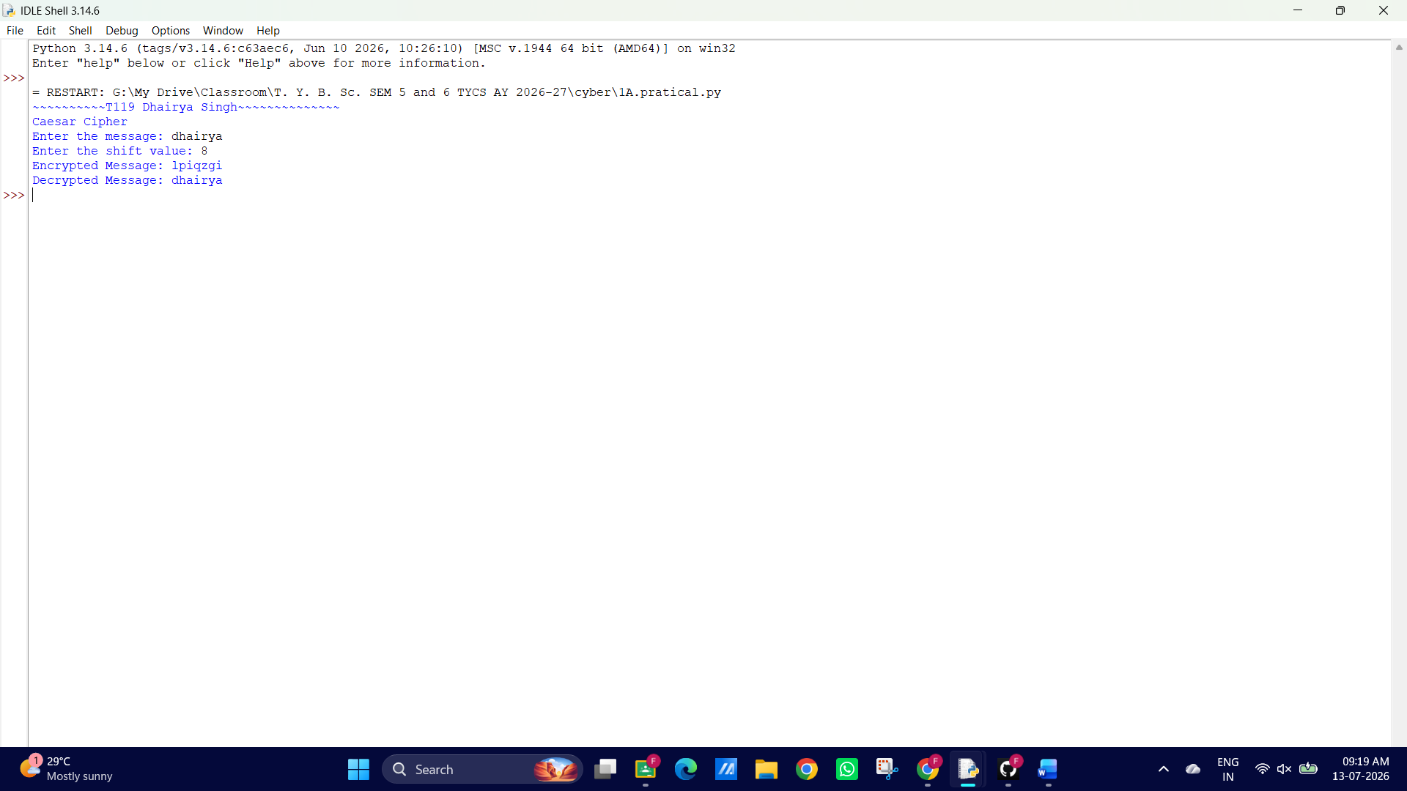

GUI:
import tkinter as tk
from tkinter import messagebox

# ---------------- Caesar Cipher Functions ---------------- #

def caesar_encrypt(text, shift):
result = ""

for ch in text:
if ch.isalpha():
if ch.isupper():
result += chr((ord(ch) - ord('A') + shift) % 26 + ord('A'))
else:
result += chr((ord(ch) - ord('a') + shift) % 26 + ord('a'))
else:
result += ch

return result

def caesar_decrypt(text, shift):
return caesar_encrypt(text, -shift)

# ---------------- Button Functions ---------------- #

def encrypt_text():
try:
text = txt_message.get()
shift = int(txt_shift.get())

encrypted = caesar_encrypt(text, shift)

result_box.config(state="normal")
result_box.delete(0, tk.END)
result_box.insert(0, encrypted)
result_box.config(state="readonly")

except ValueError:
messagebox.showerror("Error", "Enter a valid shift value.")

def decrypt_text():
try:
text = txt_message.get()
shift = int(txt_shift.get())

decrypted = caesar_decrypt(text, shift)

result_box.config(state="normal")
result_box.delete(0, tk.END)
result_box.insert(0, decrypted)
result_box.config(state="readonly")

except ValueError:
messagebox.showerror("Error", "Enter a valid shift value.")

def clear_all():
txt_message.delete(0, tk.END)
txt_shift.delete(0, tk.END)

result_box.config(state="normal")
result_box.delete(0, tk.END)
result_box.config(state="readonly")

# ---------------- GUI ---------------- #

root = tk.Tk()
root.title("Classical Substitution Cipher - Caesar Cipher")
root.geometry("500x320")
root.resizable(False, False)

title = tk.Label(
root,
text="Classical Substitution Cipher (Caesar Cipher)",
font=("Arial", 15, "bold")
)
title.pack(pady=15)

# Message
tk.Label(root, text="Enter Message:", font=("Arial", 11)).pack()

txt_message = tk.Entry(root, width=50, font=("Arial", 11))
txt_message.pack(pady=5)

# Shift
tk.Label(root, text="Shift Value:", font=("Arial", 11)).pack()

txt_shift = tk.Entry(root, width=10, font=("Arial", 11))
txt_shift.pack(pady=5)

# Buttons
frame = tk.Frame(root)
frame.pack(pady=15)

btn_encrypt = tk.Button(
frame,
text="Encrypt",
width=12,
bg="lightgreen",
command=encrypt_text
)
btn_encrypt.grid(row=0, column=0, padx=10)

btn_decrypt = tk.Button(
frame,
text="Decrypt",
width=12,
bg="lightblue",
command=decrypt_text
)
btn_decrypt.grid(row=0, column=1, padx=10)

btn_clear = tk.Button(
frame,
text="Clear",
width=12,
bg="tomato",
command=clear_all
)
btn_clear.grid(row=0, column=2, padx=10)

# Result
tk.Label(root, text="Result:", font=("Arial", 11, "bold")).pack()

result_box = tk.Entry(root, width=50, font=("Arial", 11), state="readonly")
result_box.pack(pady=5)

root.mainloop()

Output:
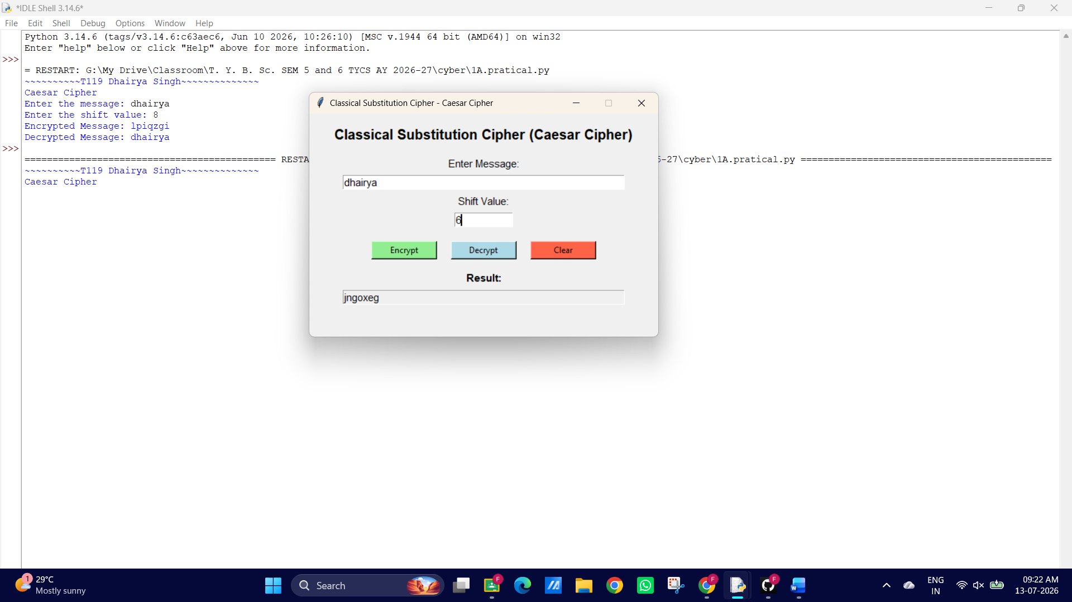
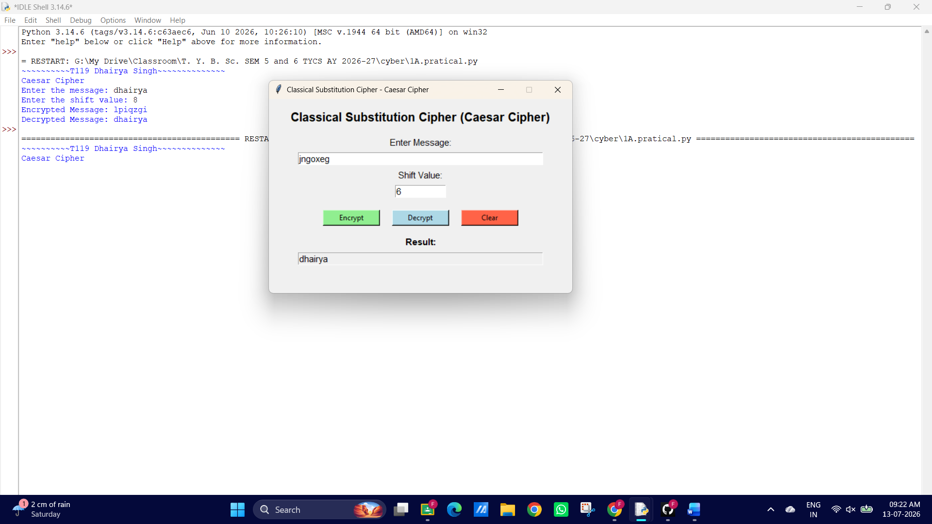
1. B Design and implement algorithms to encrypt and decrypt messages using transposition techniques.

Code:
print("# ---------------- T119 Dhairya Singh ---------------- #")
print("Rail Fence Cipher (Transposition Technique)")
print()
# Encryption Function
def encrypt(text, key):
rail = [['\n' for i in range(len(text))] for j in range(key)]

direction_down = False
row, col = 0, 0

for char in text:
if row == 0 or row == key - 1:
direction_down = not direction_down

rail[row][col] = char
col += 1

if direction_down:
row += 1
else:
row -= 1

result = ""
for i in range(key):
for j in range(len(text)):
if rail[i][j] != '\n':
result += rail[i][j]

return result

# Decryption Function
def decrypt(cipher, key):
rail = [['\n' for i in range(len(cipher))] for j in range(key)]

direction_down = None
row, col = 0, 0

for i in range(len(cipher)):
if row == 0:
direction_down = True
if row == key - 1:
direction_down = False

rail[row][col] = '*'
col += 1

if direction_down:
row += 1
else:
row -= 1

index = 0
for i in range(key):
for j in range(len(cipher)):
if rail[i][j] == '*' and index < len(cipher):
rail[i][j] = cipher[index]
index += 1

result = ""
row, col = 0, 0

for i in range(len(cipher)):
if row == 0:
direction_down = True
if row == key - 1:
direction_down = False

result += rail[row][col]
col += 1

if direction_down:
row += 1
else:
row -= 1

return result

text = input("Enter the message: ")
key = int(input("Enter the key (number of rails): "))

encrypted = encrypt(text, key)
print("Encrypted Message:", encrypted)

decrypted = decrypt(encrypted, key)
print("Decrypted Message:", decrypted)

Output:
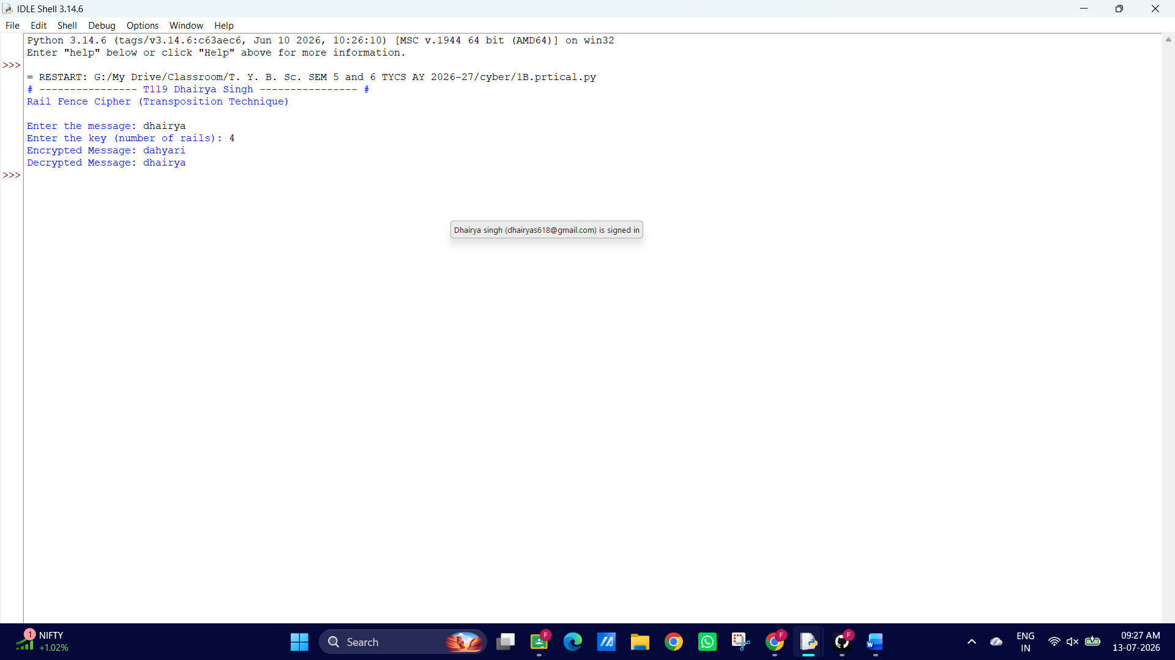

GUI:
import tkinter as tk
from tkinter import messagebox

# ---------------- Encryption ---------------- #

def encrypt(text, key):
if key <= 1:
return text

rail = [['\n' for _ in range(len(text))] for _ in range(key)]

row = 0
col = 0
direction_down = False

for ch in text:

if row == 0 or row == key - 1:
direction_down = not direction_down

rail[row][col] = ch
col += 1

if direction_down:
row += 1
else:
row -= 1

result = ""

for i in range(key):
for j in range(len(text)):
if rail[i][j] != '\n':
result += rail[i][j]

return result

# ---------------- Decryption ---------------- #

def decrypt(cipher, key):
if key <= 1:
return cipher

rail = [['\n' for _ in range(len(cipher))] for _ in range(key)]

row = 0
col = 0
direction_down = None

# Mark zig-zag path
for i in range(len(cipher)):

if row == 0:
direction_down = True
if row == key - 1:
direction_down = False

rail[row][col] = '*'
col += 1

if direction_down:
row += 1
else:
row -= 1

# Fill marked places
index = 0
for i in range(key):
for j in range(len(cipher)):
if rail[i][j] == '*' and index < len(cipher):
rail[i][j] = cipher[index]
index += 1

result = ""
row = 0
col = 0

for i in range(len(cipher)):

if row == 0:
direction_down = True
if row == key - 1:
direction_down = False

result += rail[row][col]
col += 1

if direction_down:
row += 1
else:
row -= 1

return result

def encrypt_text():
try:
text = message_entry.get()
key = int(key_entry.get())

if key < 2:
messagebox.showerror("Error", "Key must be greater than 1.")
return

result = encrypt(text, key)

result_entry.config(state="normal")
result_entry.delete(0, tk.END)
result_entry.insert(0, result)
result_entry.config(state="readonly")

except ValueError:
messagebox.showerror("Error", "Enter a valid key.")

def decrypt_text():
try:
text = message_entry.get()
key = int(key_entry.get())

if key < 2:
messagebox.showerror("Error", "Key must be greater than 1.")
return

result = decrypt(text, key)

result_entry.config(state="normal")
result_entry.delete(0, tk.END)
result_entry.insert(0, result)
result_entry.config(state="readonly")

except ValueError:
messagebox.showerror("Error", "Enter a valid key.")

def clear():
message_entry.delete(0, tk.END)
key_entry.delete(0, tk.END)

result_entry.config(state="normal")
result_entry.delete(0, tk.END)
result_entry.config(state="readonly")

root = tk.Tk()
root.title("Rail Fence Cipher - Transposition Technique")
root.geometry("550x330")
root.resizable(False, False)

title = tk.Label(
root,
text="Rail Fence Cipher (Transposition Technique)",
font=("Arial", 16, "bold")
)
title.pack(pady=15)

tk.Label(root, text="Enter Message:", font=("Arial", 11)).pack()

message_entry = tk.Entry(root, width=50, font=("Arial", 11))
message_entry.pack(pady=5)

tk.Label(root, text="Enter Key (Rails):", font=("Arial", 11)).pack()

key_entry = tk.Entry(root, width=10, font=("Arial", 11))
key_entry.pack(pady=5)

frame = tk.Frame(root)
frame.pack(pady=15)

encrypt_btn = tk.Button(
frame,
text="Encrypt",
width=12,
bg="lightgreen",
command=encrypt_text
)
encrypt_btn.grid(row=0, column=0, padx=10)

decrypt_btn = tk.Button(
frame,
text="Decrypt",
width=12,
bg="lightblue",
command=decrypt_text
)
decrypt_btn.grid(row=0, column=1, padx=10)

clear_btn = tk.Button(
frame,
text="Clear",
width=12,
bg="tomato",
command=clear )
clear_btn.grid(row=0, column=2, padx=10)
tk.Label(root, text="Result:", font=("Arial", 11, "bold")).pack()
result_entry = tk.Entry(root, width=50, font=("Arial", 11), state="readonly")
result_entry.pack(pady=5)
root.mainloop()
Output:
